For this assignment, you will consider some of the ethical and legal aspects of disaster management.
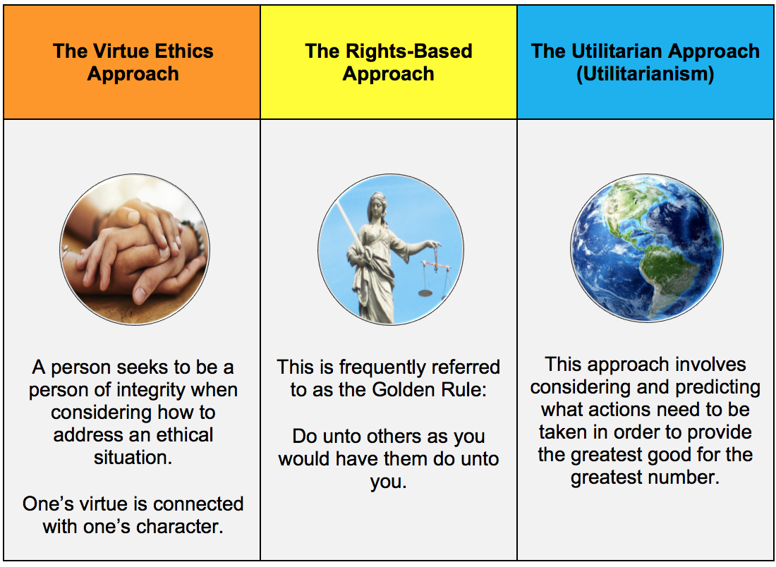

Choose one of the articles to read and respond to for this week's assignment. [5 Articles have been attached]

Answer the following questions in a well-written paper:
- Which ethical approach do you think is the most useful for nurses when they plan for or deal with a natural disaster, and why did you select that approach?
- Discuss some ways nurses can prevent developing moral distress when their personal decision-making processes conflict with the processes that must be used during times of disaster.
- Discuss how the American Nurses Association (ANA) Code of Ethics provides guidance for nurses who respond to natural disaster.

(PDF HAS BEEN ATTACHED)

INSTRUCTIONS:
Use APA format.
Your paper should be 2–3 pages in length, not including the title page and references page. Include an introduction and a conclusion to your paper.
Review the rubric for more information on how your paper will be graded. (attached)

